**TECHNICAL REPORT ON SALES ANALYSIS PERFORMANCE FOR PECARSON WINE FOR THE YEAR 2023/2024.**

**Introduction**

The purpose of this report is to present a detailed analysis of salesperson performance, best customers, total sales by type, sales trend report by quarter, region with highest sales, and sales by brand. The idea is to evaluate top performing products and regions, analyze the sales trend and its fluctuations and provide insights and actionable recommendations that will improve sales for the coming year.

**Story of the data**

The data is obtained from a public data set and tells a story around wine sold by the PECARSON store by different sales persons and their performance. It also tells a story around the type and brand of wine sold and sales trends.

**Data Structure:** The data is arranged with rows representing Order IDs, and columns showing Customer Names, Order ID, Date, Customer Region, Wine type, Wine Brand, Bottle size, Unit sold, Unit Price, Sales Channel, Sales Rep, and Total sales.

**Data Splitting and Preprocessing.**

**Data Split:** The data was split into two categories. Category one is the Independent values while category two is the dependent value.

**Category One** - Independent Variables

Customer Name

Customer Region

Wine Type

Wine Brand

Sales Rep

Order ID

**Category Two** - Dependent Variables

Date

Bottle Size

Unit Sold

Unit Price

Sales Channel

Total Sales

**Data Cleaning:**

I made sure the headings were well spelt out.

**Industry context:** The data is a retail data set that talks on the sales of wine and its analysis will help to improve sales in the coming year.

**Stakeholders:** Marketing department, Line Managers, Sales rep

**Value to the Industry:** The insights will help the team make better decisions in the coming year.

**Pre-Analysis**

* What is the Best Sales by Brand?
* What is the Best Sales by Type?
* Who is the Best Sales Rep?
* Who are the Top 3 Customers?
* What is the Sales Monthly or Quarterly?
* Which Region sold the Highest?

**Observation:**

* Charlie Perform best for the year 2023/2024 with a total revenue of $2,167,268.74
* The Best Region is the West with a total sales of $2,214,185.
* The Best Month is May with Total Sales of $944,792 while the least performing month was in February with a down sales of $840,575.
* The best Quarter was the second quarter with a total sales of $2,705,880.
* The Best Wine Brand is Crimson Cellars and it generated a revenue of $2,168,056.81 while the Best Wine by Type is the White wine with a total sales of $2,702,792.
* The Least sales wine is the Rose wine with revenue of $2,661,225.
* The Least performing Region is the South Region with a revenue of $2,101,731.
* Customer of the year is Customer 7305 and this customer bought a total Wine of $1,200.
* The Least performing Sales person is Ethan.
* The least performing brand is the Chateau Noir wine with a revenue of $2,095,271.

**Recommendations:**

* Charlie performs best for the year 2023/2024. I recommend him for a salary review or compensation to enable other sales people to do more.
* I do recommend that the best Region, which is the West, should be monitored for effective distribution of wine to distributors.
* We can replicate measures implemented in May in Months with Low Sales to improve sales in the coming year.
* More measures should be in place to avoid running out of Crimson brand as this brand generated the highest revenue.
* I recommend Ethan be sent on a training course to improve his sales performance for the coming year.
* More Advertisements should be done on the Chateau wine to improve its revenue generation.
* I recommend the best customer should be given a 2% discount on his next purchases.
* More Advertisements should be done on the Rose wine to improve its sales.
* Finetune the Sales person in the South region and transfer the person to meet the sales person in West to learn more about the customers retention and sales strategy.
* Gather customer feedback to understand pain points and improve on the Chateau Noir.
* Invest more in successful regions like the West.

**Data Visualization and Charts:**

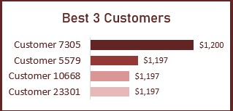

The bar chart shows the Top 3 customers of Pecarson that generated the most revenue. From the chart, “Customer 7305” is the best customer for the year 2023/2024 with revenue of $1,200. While “Customer 5579”, Customer 10668, and Customer 23301 generated revenue of $1,197 respectively.

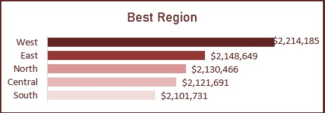

The chart shows the best region and amount of revenue generated by each region. The West region is the best region with total sales of $2,214,185 while the South generated the least revenue of $2,101,731.

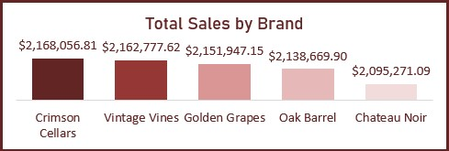

The chart shows the sales of each brand and the revenue generated. Crimson Cellars generated the highest revenue with $2,168,056,.81, followed by the Vintage vines with $2,162,777.62, Golden Grapes generated $2,151,947.15, Oak Barrel generated $2,138,669.90 and Chateau Noir generated the least revenue by brand type with $2.095,271.09 in total for the year 2023/2024.

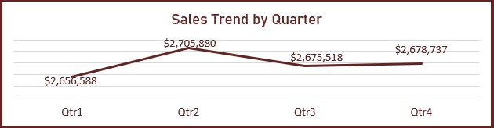

The line chart shows the sales by quarter and the Revenue generated for each quarter. From the trend, the second quarter has the highest sale with $2,705,880 in total revenue.The first quarter generated the least revenue with $2,656,588.

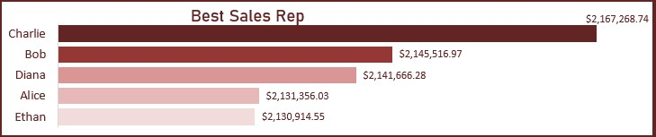

This chart shows the top performing sales person for the year 2023/2024. Charlie performs as the best sales person with $2,167,268.74 revenue generated while Ethan is the least performing sales person for the year.

**Conclusion**

The analysis provides insights into key salesperson performance, region and brand performance. By implementing the recommended strategies, the business can optimize revenue growth, improve market positioning, and enhance customer satisfaction.

Reference: kaggle.com